Lecture 12

12.PartitionsTaskSolving-CompressionTools-RedirectTopic

**Partition table reviewed**

* **1 partition table for 1 Hard Drive** contains information (size, file system etc.) of all the partitions in the drive.
* “w” or write in fdisk performs this task
* 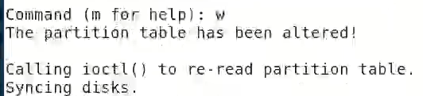
* $ fdisk -l 🡪 to list all the partitions available
* When “fdisk” utility is exited the same information is updated in “Kernel Table” with “partx -a” or “partprobe” command. These commands take this information from partition table.
* Partition table is in **Hard disk** or storage and Kernel Table is in **RAM**
* From Kernel Table **OS** also know about the changes occurred
* In case machine is rebooted,
  + The machine booting process then takes the required information from “Partition Table” in this case no need to run partx -a command. This command to update Kernel Table without rebooting. Tip: the industry standard is never reboot the machine
* In THEL 7 partx -a ha alternative called “**$ partprobe -s”**
* “sdb<number>”is driver os the specific partition . it is like a door to that partition.
* **Then format the partition mkfs.ext4**
* **Mount the partitions $ mount**
* **Then update the fstab file so that the booting process /etc/fstab is updated, vi /etc/fstab**
* It has 6 fields which needed to be updated against each new partition

**-**

**fstab explained**

* File System Table – fstab
* 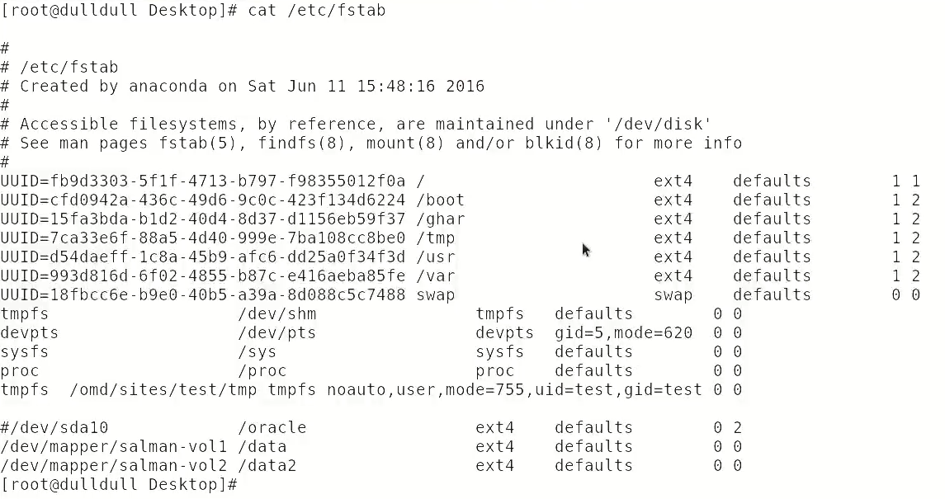
* mount command loads the mounting point in RAM temporary
* to solve this problem, fstab file is updated so that each time rebooting doesn’t effect the issue to access that specific partition
* fstab mapps all the entries in it and automounts the specific partition.
* 

**Compression tools**

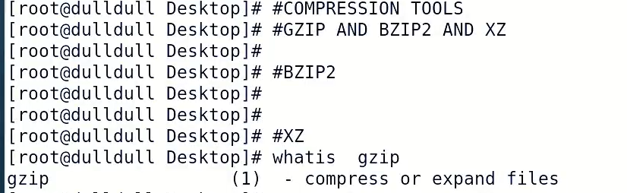

* These tools are basically commands.
* It compresses and reduces the size of the files,
* It is shrinking - technical it is called **“ to deflate”** it reduces the size of a specific file
* کسی شئے کی بھری ہوئی ہوا نکالنا
* $ gzip, $ bzip 🡪 these are the commands
* In everyday scenario Sys Admin used to compress the files on server to save disk space
* Touch file{1..20} 🡪 to create multiple no of files, {} are called wildcards (details in scripting)
* 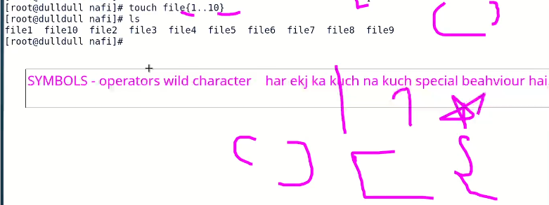
* {} curly braces mean to “expand”
* To delete, $ rmdir <directory_name>{1..100}
* **# Redirection >**
* Openside > closed side 🡪 open side passes information to closed side
* Closed side < open side
* 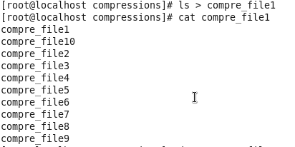
* Direct contents of a file to another file
* 
* “>” replaces the existing text or adds new text or content into an empty file
* “>>” appends the content under existing file
* “>” <file_name> can overwrite whole data in a file , $ > file.txt
* **compression**
* $ gzip <file_name>
* $ bzip2 <file _name>
* **Un-compression**
* $ gunzip <file_name.gz>
* $ bunzip2 <file_name.extension>
* **To compress contents of a directory**
* **To unzip**
* **$ unzip <file_name>**
* 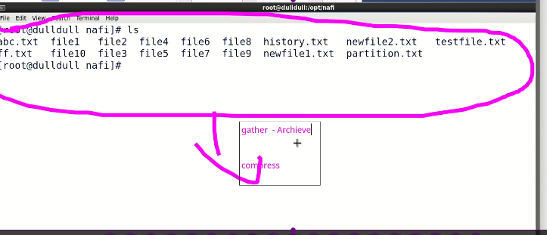
* Tip:
* To check availability of a command
* $ zip <tab><tab>
* 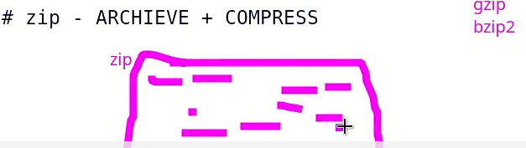
* To zip
* $ zip all.zip<space> * 🡪 puts in same folder
* For specific no of files

$ zip files.zip <1st file_name> <2nd file_name>